Thomas A. Goodwin Band Scholarship
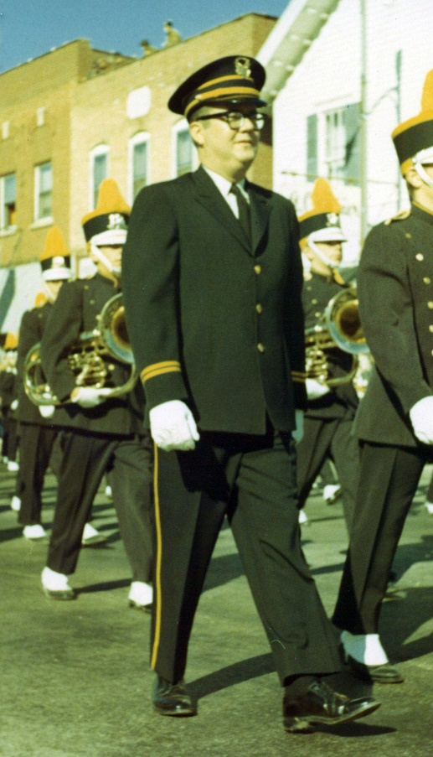
Tom Goodwin was a life-long drummer and the New Lenox Junior High Band director for 31 years.
He had a deep love of music, especially the drums!
In his honor, Shorewood HUGS is looking for a 7th grade student who is eager to further his/her music education, and displays leadership skills to share with the band during their eighth grade year.

2 - $250 Scholarships
(Paid directly to the private lesson teacher to help
with costs of private lessons)

---------------------------------------------------------------------------------------------------------------------------------
Application Form
(Application Form and Essay due no later than March 31st)

Please complete entry form and short essay and mail to the address below or email to susancoyle10@msn.com by March 31st. Winners will be chosen by the HUGS scholarship committee and notified in May.
If you have any questions, please call Sue Coyle at 815-347-4826 or go to our website at www.shorewoodhugs.org.

Student’s Name: __________________________________________________ Age:_____________
School: ___________________________________________________________Grade:____________
Best Phone Number: _____________________________ Email: _____________________________
Private Lesson Teacher: ___________________________ Instrument__________________________
Essay:
Please tell us in 300 words or less what playing in one of the New Lenox Bands means to you. Also include how you plan on using your leadership qualities in band during your 8th grade year.
Please mail form and essay to:
Shorewood HUGS Band Scholarship
1147 Brook Forest Ave., #174
Shorewood, IL 60404

The family of Tom Goodwin is so happy to encourage the dreams of a musician!

