Thomas A. Goodwin Band Scholarship
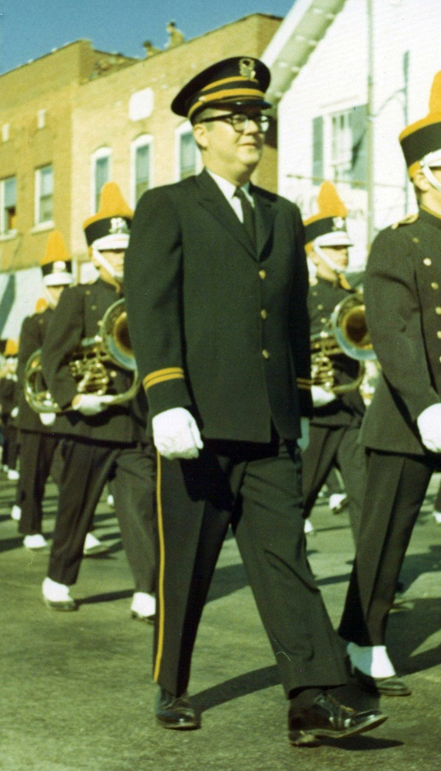
Tom Goodwin was a life-long drummer and the New Lenox Junior High Band director for 31 years.
He had a deep love for music, especially the drums!
In his honor, Shorewood HUGS is looking for an 8th grade student who is eager to further his or her music education and displays leadership skills to share with the band during their eighth grade year.

2 - $500 Scholarships
(Paid directly to the private lesson teacher to help
with cost of private lessons)


---------------------------------------------------------------------------------------------------------------------------------
Application Form
(Application Form and Essay due no later than September 1st)

Please complete entry form and short essay and mail to the address below by September 1st.
Winners will be chosen by the HUGS scholarship committee and notified in September.
If you have any questions, please call Sue Coyle at 815-347-4826 or go to our website at www.shorewoodhugs.org.

Student’s Name:_________________________________ Age: ______________________________
School: ________________________________________ Grade: ____________________________
Best Phone Number: _____________________________ Email: ____________________________
Private Lesson Teacher: ___________________________ Instrument_________________________
Essay:
Please tell us in 300 words or less what playing in the New Lenox Band means to you. Also include how you plan on using your leadership qualities in band during your 8th grade year.
Please mail form and essay to:
Shorewood HUGS Band Scholarship
1147 Brook Forest Ave., #174
Shorewood, IL 60404

The family of Tom Goodwin is so happy to encourage the dreams of a musician!

